|  |  |  |  |  |  |
| --- | --- | --- | --- | --- | --- |
| Date | 6-Dec-22 | | | Tester Name | Richard Belanger |
| Environment | Penfax - Test | | | Login used | TEST2 |
| Operating System | Windows | Version: | Update: | | |
| Software Used | Edge | Version: | Update: | | |
| Not Applicable | Version: | Update: | | |
| Release version | 22.4.1 | | | | |
| Title | M13.01 Death of Deferred married member not eligible to retire | | | | |
| Test Type | Regression | | | | |
| Test Scenario | Member will be terminated due to death and beneficiary will receive payment | | | | |
|  |  | | | | |
| Expected Results | Beneficiary will receive the correct payment amount | | | | |
| Pass/Fail | Pass | | | JIRA# | N/A |

Describe your steps with screenshots:

Deferred Married Member not eligible for pension

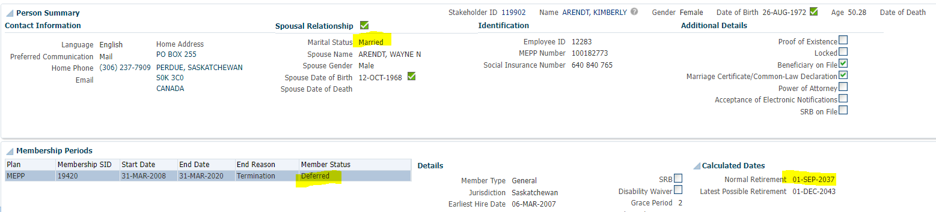

Member terminated due to death

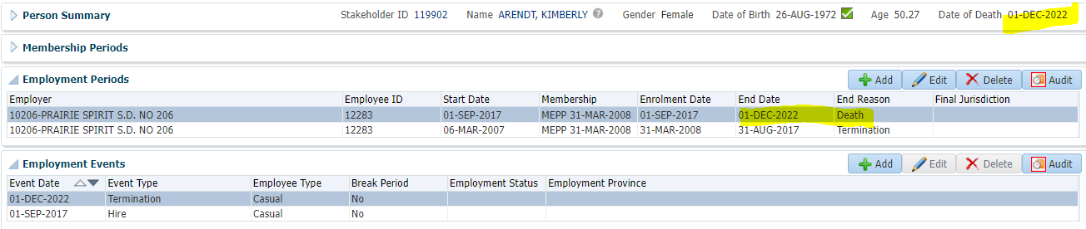

To Benefit Calculation>Calculate

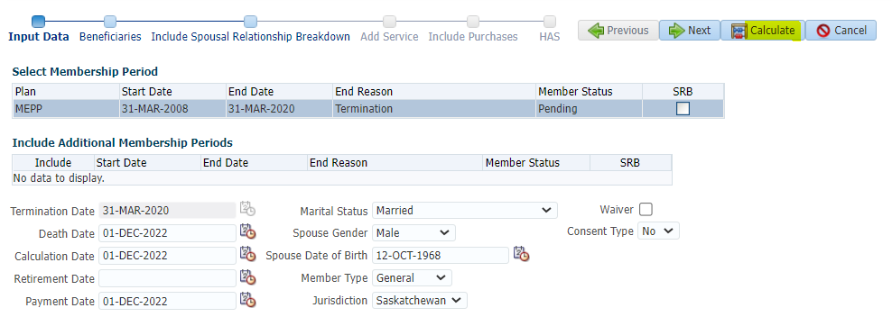

Processed

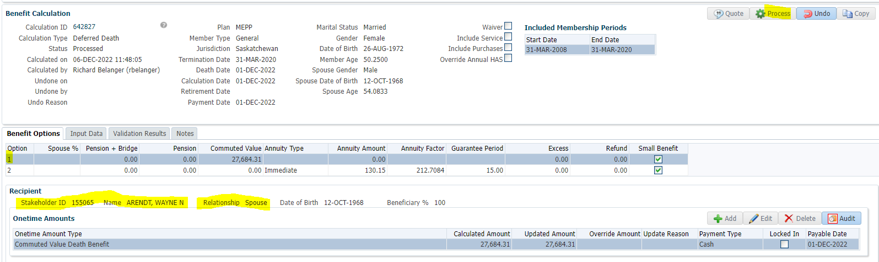

To Benefit Selection>Next

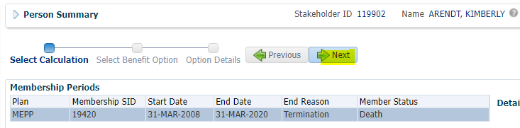

Choose Option add payment date>Next

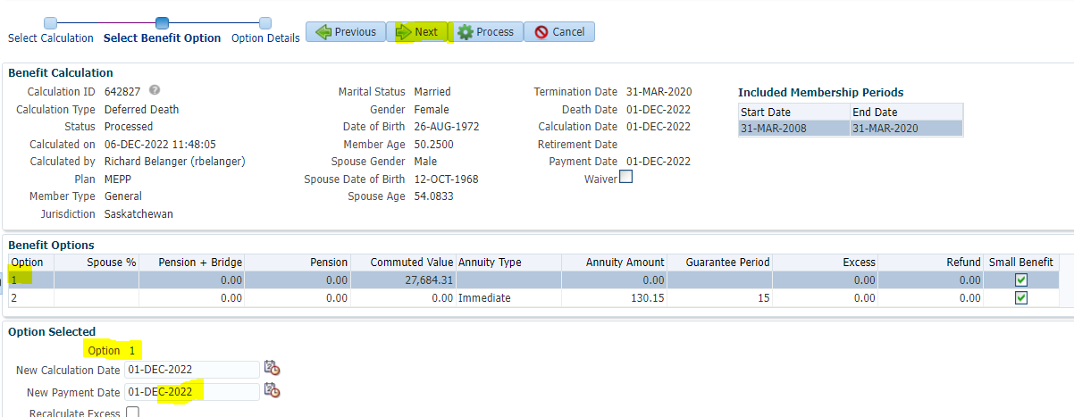

Add Payment Instructions>Process

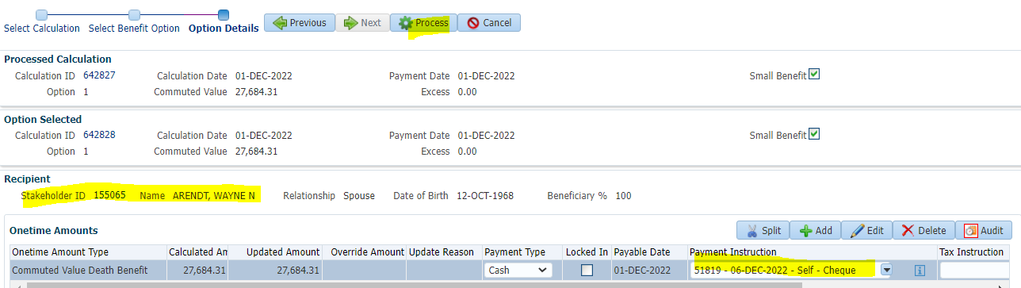

Processed

To Spouse>Benefit Recipient>Submit for Approval and Approve the Payment line>To Summary>Authorize

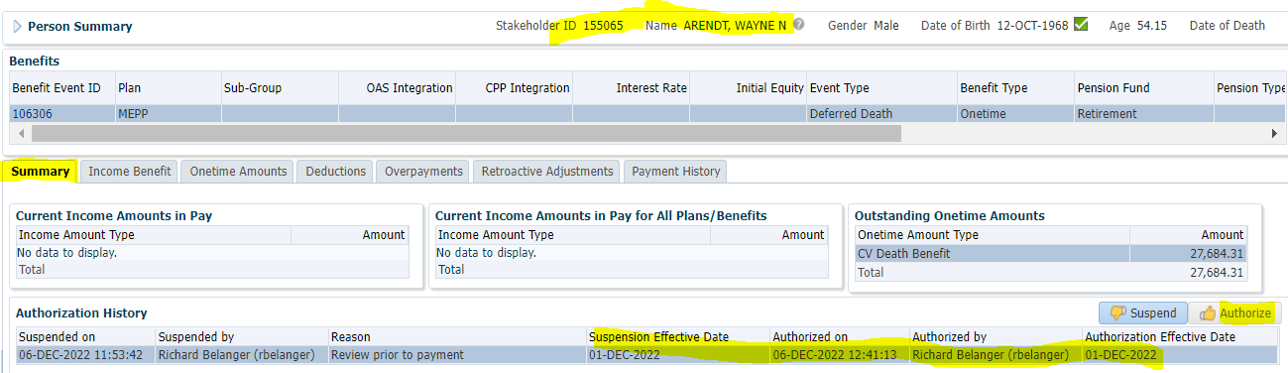

Payment History after payment run

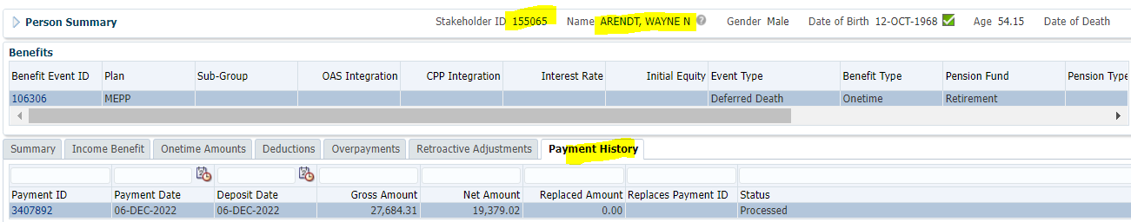

Tax Rates

0.00-4,999.99 = 10%

5,000.00- 14,999.99 = 20%

15,000.00+ = 30%

Payment amount is greater than $15,000; 30% Tax will be taken from the Gross Amount

27684.31 x 30% = 8,305.29; 27684.31 – 8,305.29 = **$19,379.02**